  DIGITAL IMAGE PROCESSING  PROJECT REPORT | Group Members:  233531-Eman Qazi  233531-Aimah Bilal  233581-Amna Noor

FOOD IMAGE PREPROCESSING AND ANALYSIS USING DIGITAL IMAGE PROCESSING TECHNIQUES

1. Problem Statement
Digital images have become an essential source of information in modern computer vision and machine learning applications. In food recognition systems, image quality plays a critical role in determining the accuracy of analysis and classification. However, images captured using mobile devices are often affected by poor lighting conditions, image noise, low contrast, shadows, and complex backgrounds. These issues make it difficult to accurately identify food objects and extract meaningful information from images.
The primary objective of this project is to develop a comprehensive Digital Image Processing (DIP) pipeline that improves the quality of food images before they are analyzed further. The system applies multiple preprocessing and analysis techniques such as image enhancement, denoising, edge detection, segmentation, contour extraction, and frequency domain analysis. These techniques help improve image quality, highlight important food features, and isolate food objects from the background.
This project demonstrates how various Digital Image Processing methods can be combined to transform raw food images into cleaner and more informative representations that can later be used for machine learning and computer vision applications.

2. Dataset
The dataset used in this project consists of food images collected from publicly available food datasets and online image repositories. The images represent various food categories including biryani, pizza, burgers, sandwiches, pasta, rice dishes, desserts, and curry-based meals. Since the images originate from different sources, they contain variations in lighting conditions, image quality, camera angles, object sizes, and backgrounds.
The input images are RGB color images stored in JPEG and PNG formats. Because the image resolutions vary significantly, a preprocessing step is required to standardize all images before analysis. Therefore, each image is resized to a fixed resolution of 224 × 224 pixels. This standardization ensures consistency throughout the processing pipeline and allows fair comparison between different processing stages.
The dataset was selected because food images provide a practical scenario for demonstrating image enhancement, segmentation, and feature extraction techniques. The diversity of the images also helps evaluate the effectiveness of the implemented algorithms under different real-world conditions.

Dataset Characteristics
Property | Description
Image Type | RGB Color Images
File Formats | JPG, JPEG, PNG
Image Size | Variable
Resized Dimension | 224 × 224 Pixels
Categories | Biryani, Pizza, Burger, Sandwich, Pasta, Curry, Rice, Desserts
Source | Public Datasets and Internet Images

3. Algorithm Description
The proposed system consists of a sequence of Digital Image Processing techniques that are applied to each image. Every stage contributes to improving image quality and preparing the image for further analysis.

3.1 Image Loading and RGB Conversion
The first step involves loading the image using the OpenCV library. Since OpenCV reads images in BGR format by default, the image is converted to RGB format immediately after loading. This conversion ensures color consistency throughout the processing pipeline and produces images that are compatible with standard visualization and machine learning frameworks.
The image loading stage serves as the foundation of the entire preprocessing workflow because all subsequent operations depend on accurate image acquisition and color representation.

3.2 Image Resizing
Images collected from different sources often have varying resolutions. These variations can increase computational complexity and make image comparison difficult. To address this issue, every image is resized to a fixed dimension of 224 × 224 pixels.
Resizing standardizes the dataset and ensures that all images are processed under identical conditions. This step also reduces memory usage and processing time while maintaining sufficient visual information for analysis.

3.3 Contrast Enhancement using CLAHE
After resizing, image contrast is improved using Contrast Limited Adaptive Histogram Equalization (CLAHE). Traditional histogram equalization sometimes over-enhances certain image regions and amplifies noise. CLAHE overcomes this limitation by dividing the image into smaller regions and enhancing each region independently while limiting excessive contrast amplification.
This technique significantly improves the visibility of food textures and details, particularly in images captured under poor lighting conditions. Enhanced contrast makes the food object more distinguishable from its surroundings and facilitates better feature extraction in later stages.

3.4 Gaussian Blur
Noise is a common problem in digital images and can negatively affect image analysis. To reduce noise, Gaussian Blur is applied using a 5 × 5 kernel. Gaussian filtering smooths intensity variations by averaging neighboring pixels according to a Gaussian distribution.
The result is a cleaner image with reduced high-frequency noise. This smoothing operation improves the effectiveness of edge detection and segmentation algorithms by minimizing unwanted pixel fluctuations.

3.5 Non-Local Means Denoising
In addition to Gaussian filtering, Non-Local Means Denoising is applied as an advanced noise reduction technique. Unlike conventional filters that consider only nearby pixels, this algorithm searches for similar patterns throughout the image and uses them to estimate pixel values.
This approach preserves important image structures and object boundaries while effectively removing noise. Consequently, the food object remains visually sharp and detailed after denoising.

3.6 Histogram Analysis
Histogram analysis is performed before and after image enhancement to evaluate changes in intensity distribution. A histogram represents the frequency of occurrence of pixel intensity values within an image.
By comparing histograms of original and enhanced images, it becomes possible to observe how contrast enhancement affects image quality. Enhanced images generally exhibit a wider intensity distribution, indicating improved contrast and better visibility.

3.7 Grayscale Conversion
The enhanced image is converted from RGB format to grayscale before performing edge detection and segmentation. Grayscale images contain only intensity information and eliminate unnecessary color information.
This simplification reduces computational requirements and allows edge detection algorithms to focus entirely on intensity variations, which are more important for identifying object boundaries.

3.8 Edge Detection
Edge detection is used to identify significant boundaries and structural features within the image. Three different techniques are implemented in this project: Canny Edge Detection, Sobel Edge Detection, and Laplacian Edge Detection.
The Canny algorithm is highly effective for detecting object boundaries while suppressing noise. The Sobel operator calculates horizontal and vertical gradients to highlight directional changes in intensity. The Laplacian operator detects rapid intensity changes regardless of direction.
Together, these methods provide a comprehensive analysis of food object boundaries and important image features.

3.9 Threshold Segmentation
Segmentation is performed using Otsu’s thresholding technique. This method automatically determines an optimal threshold value that separates the foreground object from the background.
The resulting binary image simplifies further analysis by isolating the food region and removing unnecessary background information. Effective segmentation is essential because it allows the system to focus on the object of interest.

3.10 Morphological Operations
Morphological operations are applied to improve segmentation quality. Opening operations remove small noise particles while closing operations fill gaps and holes within the segmented object.
These operations refine the segmented image and produce a cleaner representation of the food object. Improved segmentation leads to more accurate contour extraction and object analysis.

3.11 Contour Detection
Contour detection is used to identify the boundaries of segmented food objects. A contour can be described as a continuous curve joining points with the same intensity value along an object's boundary.
Contours provide useful information regarding the shape, size, and structure of food objects. They also help visualize segmentation performance and verify that the food region has been accurately isolated.

3.12 Food Segmentation
After contour detection, the segmentation mask is applied to the original image to isolate the food object from the background. This process removes irrelevant image regions and retains only the food item.
The segmented image provides a clearer representation of the object and can be used directly for feature extraction or machine learning applications.

3.13 Frequency Domain Processing (FFT)
Frequency domain analysis is performed using the Fast Fourier Transform (FFT). FFT converts the image from the spatial domain into the frequency domain, allowing image frequencies to be examined separately.
Low-frequency components represent overall image structure, while high-frequency components represent fine details and noise. This analysis demonstrates how image information can be studied beyond the spatial domain and provides insight into frequency-based filtering techniques.

3.14 Image Quality Evaluation
To quantitatively evaluate preprocessing performance, Mean Squared Error (MSE) and Peak Signal-to-Noise Ratio (PSNR) are calculated.
Mean Squared Error measures the average squared difference between corresponding pixels in the original and processed images.
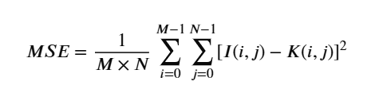
Peak Signal-to-Noise Ratio is then calculated using:
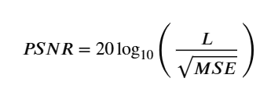
Higher PSNR values indicate that image quality has been preserved during preprocessing. These metrics provide an objective assessment of enhancement effectiveness.

4. System Design

4.1 System Architecture Diagram
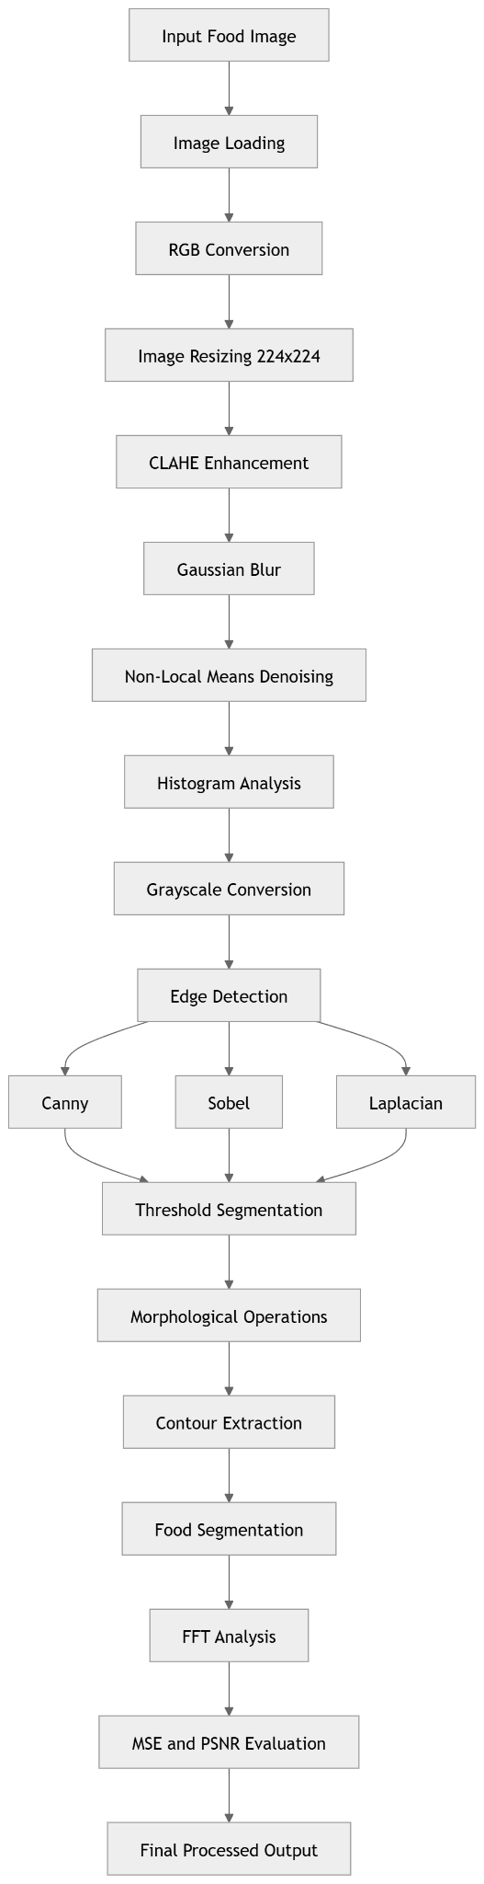

4.2 Processing Pipeline Block Diagram
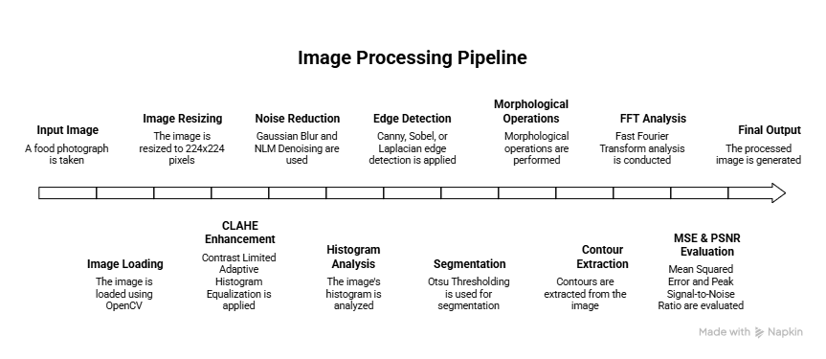

4.3 UML Class Diagram
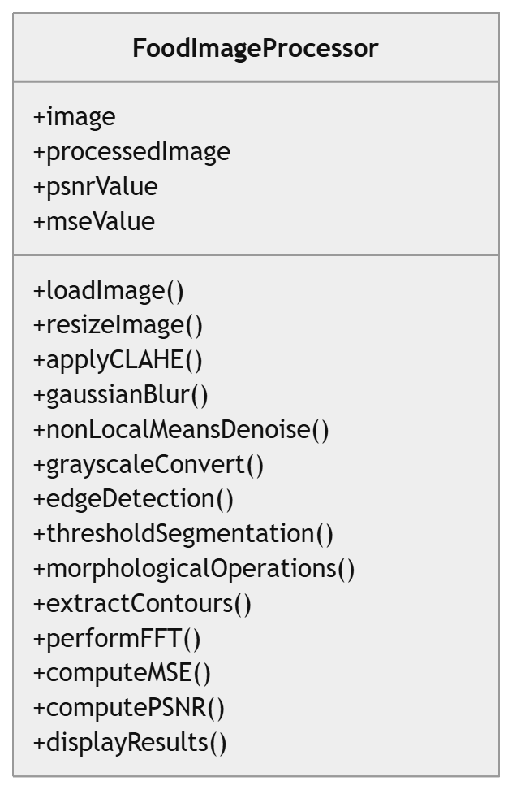

4.4 Data Flow Diagram (Level 0)
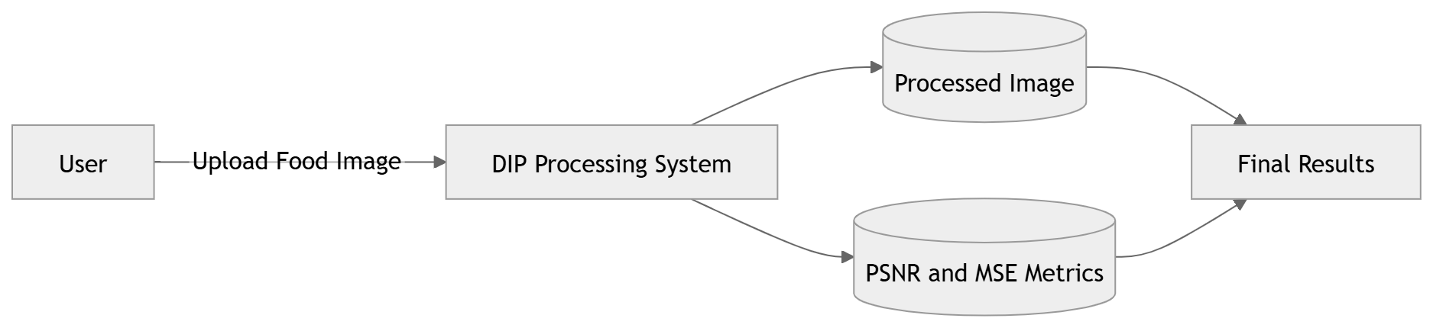

4.5 Data Flow Diagram (Level 1)
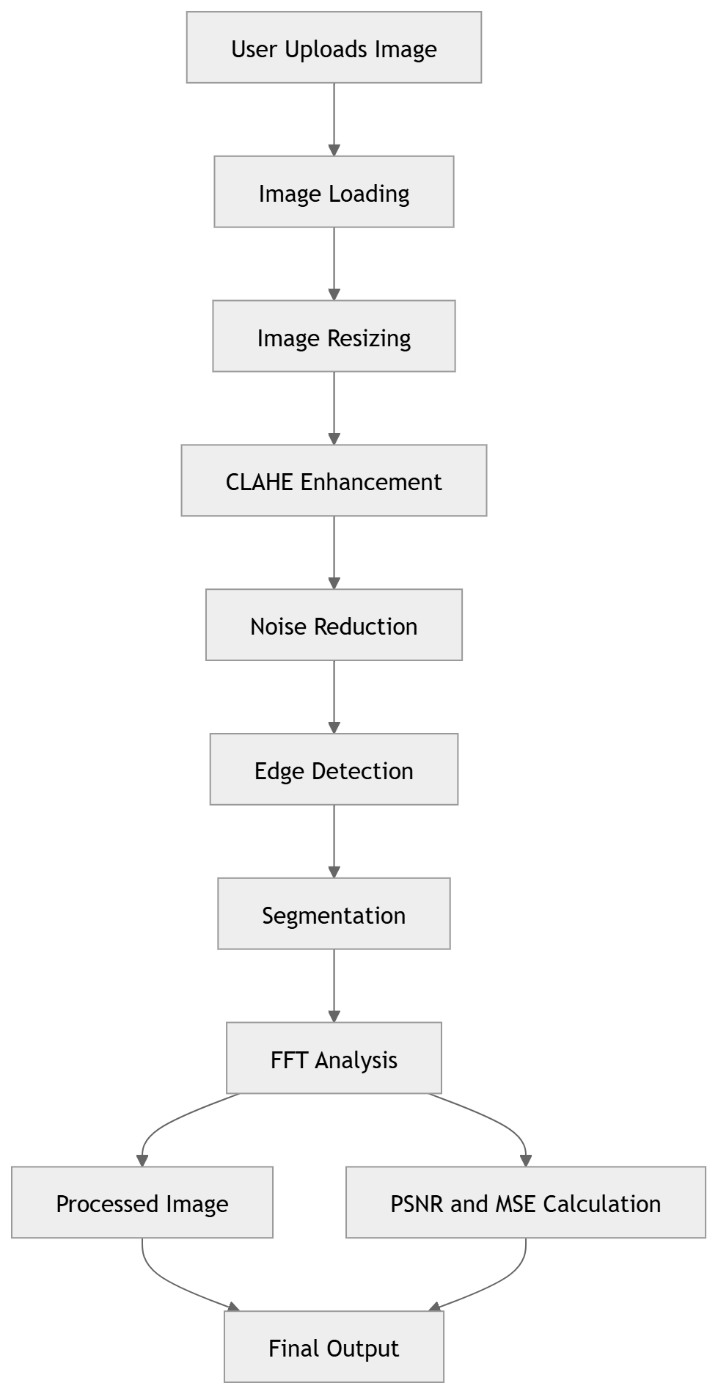

5. Implementation Details
The project was implemented entirely in Python using several image processing and visualization libraries. OpenCV was used for image manipulation, filtering, segmentation, and contour extraction. NumPy was utilized for matrix operations and numerical computations. Matplotlib was employed to visualize intermediate processing results and histograms.
The implementation follows a modular structure where separate functions are responsible for image loading, enhancement, denoising, histogram analysis, edge detection, segmentation, contour extraction, FFT processing, and metric evaluation. This modular design improves code readability and makes future modifications easier.
The preprocessing pipeline executes sequentially, allowing users to observe the effect of each processing stage on the food image.

6. Results and Analysis
The results demonstrate the effectiveness of the implemented Digital Image Processing techniques. The original images often contain uneven illumination and background noise. After applying CLAHE enhancement, image contrast improves significantly and food textures become more visible. Gaussian filtering and Non-Local Means Denoising successfully reduce unwanted noise while preserving important image details.
The edge detection algorithms effectively highlight object boundaries, allowing food structures to be clearly identified. Otsu thresholding combined with morphological operations produces accurate segmentation masks that separate food objects from the background. Contour extraction further verifies successful segmentation by outlining object boundaries.
FFT analysis provides insight into the frequency characteristics of the images and demonstrates the distinction between low-frequency image structure and high-frequency details.

Include the Following Figures
- Original Image
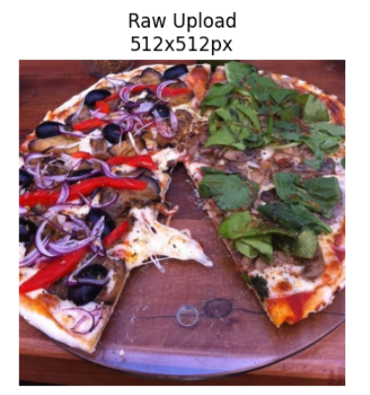
- CLAHE Enhanced Image and Gaussian Blurred Image
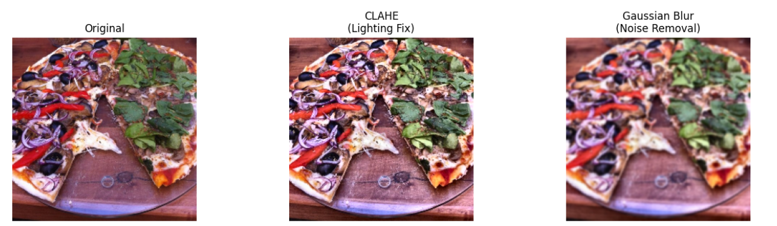
- Histogram Comparison
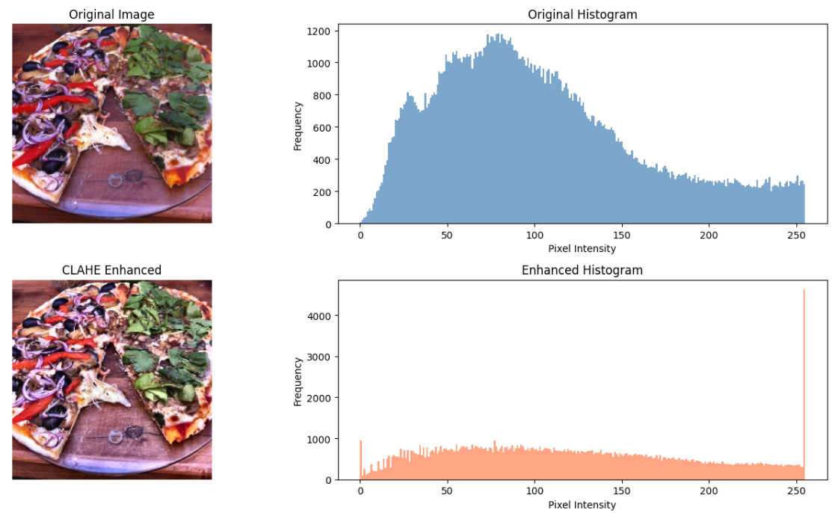
- Canny Edge Detection Result , Sobel Edge Detection Result, and Laplacian Edge Detection Result
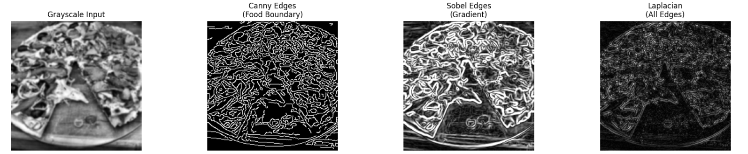
- Threshold Segmentation Result, Morphological Processing Result, Contour Detection Result, and Food Segmentation Result
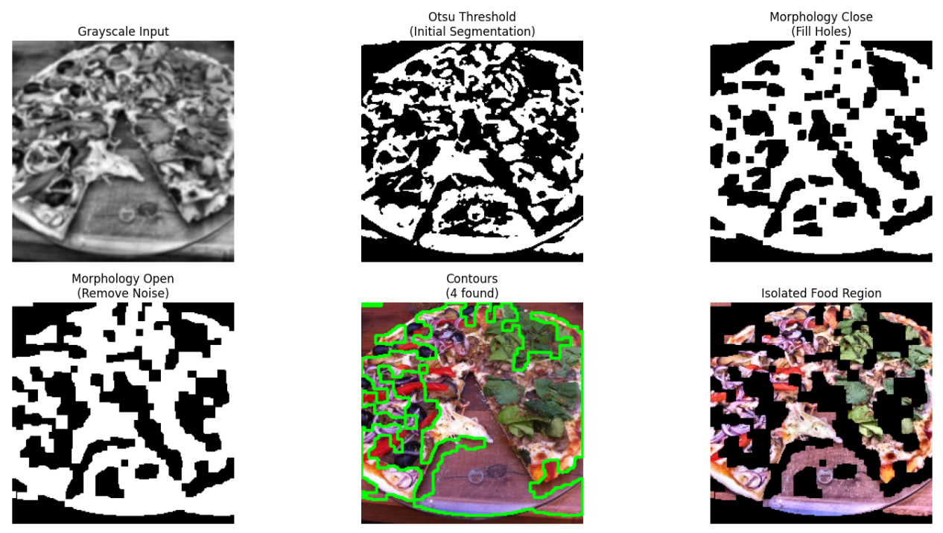
- FFT Magnitude Spectrum
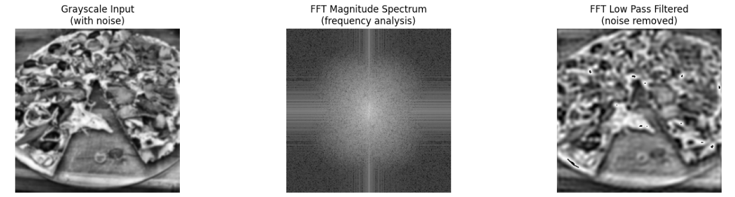

Quality Metrics Table
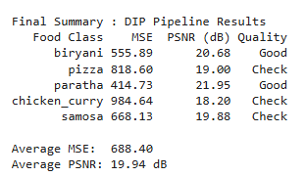
The PSNR values obtained during testing indicate that image quality is maintained while simultaneously improving visibility and reducing noise.

7. Conclusion
This project successfully demonstrates the application of multiple Digital Image Processing techniques for food image enhancement and analysis. The developed preprocessing pipeline improves image quality through contrast enhancement, noise reduction, edge detection, segmentation, contour extraction, and frequency domain analysis.
The results show that the implemented techniques effectively prepare food images for further computer vision and machine learning applications. The combination of enhancement and analysis methods provides a strong foundation for future food recognition systems.
One of the major challenges encountered during the project was handling images captured under different lighting conditions and backgrounds. Another challenge involved balancing noise reduction with detail preservation. Despite these challenges, the preprocessing pipeline produced satisfactory results across various food categories.
Future improvements may include deep learning-based segmentation methods, real-time image processing, automatic food recognition, portion size estimation, and integration with nutritional analysis systems.

8. References
- Gonzalez, R. C., & Woods, R. E. Digital Image Processing, 4th Edition.
- OpenCV Documentation.
- NumPy Documentation.
- Matplotlib Documentation.
- Otsu, N. “A Threshold Selection Method from Gray-Level Histograms.”
- Canny, J. “A Computational Approach to Edge Detection.”
- Research articles related to image enhancement, segmentation, and feature extraction.

